FACULTY EVALUATION
Programme Name: Social Entrepreneurship Development Program (SEDP)- Start Tanzania Module 3 (2nd February - 6th February 2026)
Session: Operational efficiency
Faculty Name: Dr. Diana Kageha Ominde
No. of Respondents: 16
No. of Participants: 16
Evaluation Parameter | (%) Individual Score | (%) Programme Average
Punctuality (Commencement and Completion of Sessions) | 100 | 95
How well do you understand the core concepts presented? | 92 | 87
Rate your confidence in applying the new skills learnt | 96 | 88
Degree of Faculty preparedness for the sessions | 96 | 91
Content and methodology of the program | 96 | 91
Quality of class and group discussions | 93 | 89
The information presented in the course is relevant to my work (ministry) | 96 | 91
Average scores | 96 | 90

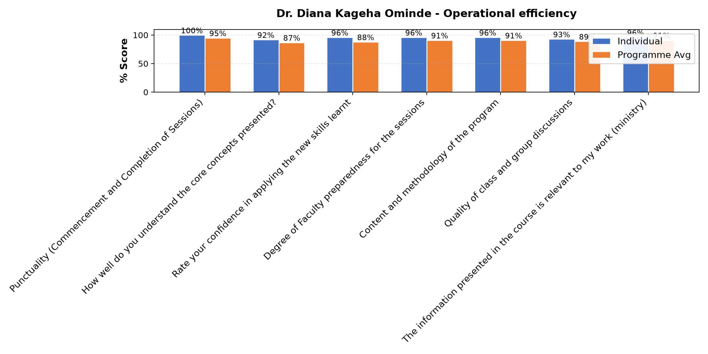

Comments & Feedback
- • If I don't collaborate with the community and don't keep the project information well-organized
- • Nothing
- • Naomba Mungu mafunzo haya niweze kuyafa nyia kazi
- • Smater
- • Kilichobaki ni utekelezaji TU Asante kwa mafundisho mazuri
- • Very good
- • Nashukuru kwa elimu niliyopata ukitoka kwa Mwalimu nitaifanyia kazi
- • Good presentation
- • She did alot
SUBMITTED THROUGH:
SBS Evaluation Automation System

